Multiple Granularity
Let's start by understanding the meaning of granularity.
Granularity: It is the size of data item allowed to lock.

Multiple Granularity:
- It can be defined as hierarchically breaking up the database into blocks which can be locked.
- The Multiple Granularity protocol enhances concurrency and reduces lock overhead.
- It maintains the track of what to lock and how to lock.
- It makes easy to decide either to lock a data item or to unlock a data item. This type of hierarchy can be graphically represented as a tree.
For example: Consider a tree which has four levels of nodes.
- The first level or higher level shows the entire database.
- The second level represents a node of type area. The higher level database consists of exactly these areas.
- The area consists of children nodes which are known as files. No file can be present in more than one area.
- Finally, each file contains child nodes known as records. The file has exactly those records that are its child nodes. No records represent in more than one file.
- Hence, the levels of the tree starting from the top level are as follows:
  - Database
  - Area
  - File
  - Record
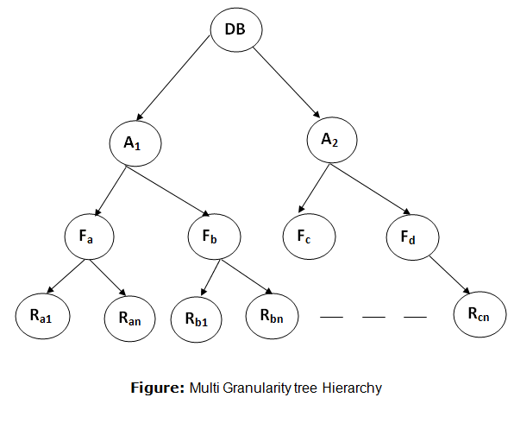In this example, the highest level shows the entire database. The levels below are file, record, and fields.
There are three additional lock modes with multiple granularity:

Intention Mode Lock
Intention-shared (IS): It contains explicit locking at a lower level of the tree but only with shared locks.
Intention-Exclusive (IX): It contains explicit locking at a lower level with exclusive or shared locks.
Shared & Intention-Exclusive (SIX): In this lock, the node is locked in shared mode, and some node is locked in exclusive mode by the same transaction.
Compatibility Matrix with Intention Lock Modes: The below table describes the compatibility matrix for these lock modes:
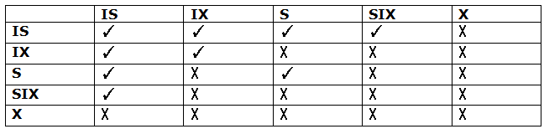
It uses the intention lock modes to ensure serializability. It requires that if a transaction attempts to lock a node, then that node must follow these protocols:
- Transaction T1 should follow the lock-compatibility matrix.
- Transaction T1 firstly locks the root of the tree. It can lock it in any mode.
- If T1 currently has the parent of the node locked in either IX or IS mode, then the transaction T1 will lock a node in S or IS mode only.
- If T1 currently has the parent of the node locked in either IX or SIX modes, then the transaction T1 will lock a node in X, SIX, or IX mode only.
- If T1 has not previously unlocked any node only, then the Transaction T1 can lock a node.
- If T1 currently has none of the children of the node-locked only, then Transaction T1 will unlock a node.
Observe that in multiple-granularity, the locks are acquired in top-down order, and locks must be released in bottom-up order.
- If transaction T1 reads record R_{a9} in file F_{a}, then transaction T1 needs to lock the database, area A₁ and file F_{a} in IX mode. Finally, it needs to lock R_{a9} in S mode.
- If transaction T2 modifies record R_{a9} in file F_{a}, then it can do so after locking the database, area A₁ and file F_{a} in IX mode. Finally, it needs to lock the R_{a9} in X mode.
- If transaction T3 reads all the records in file F_{a}, then transaction T3 needs to lock the database, and area A in IS mode. At last, it needs to lock F_{a} in S mode.
- If transaction T4 reads the entire database, then T4 needs to lock the database in S mode.


